Quincey Epley

Dean David Richards

HONR 3020-097

28 April 2021

Tarot Cards and Storytelling

The origin of the tarot is debated. Some believe it was brought to Europe from the Egyptians or the Arabs. Others believe the decks were invented in 15th century Italy. Wherever it originated, it started as a regular card game, where the object is to get the most points. It is vaguely similar to the modern game of Bridge. The Tarot wasn’t used for divination until the 1700s, when Jean Baptiste Alliette published a guide to using tarot for divination under the pseudonym Etteilla. According to the article “A Brief History of Tarot Cards,” this guide gave each of the cards meaning, related to the four elements and astrology, inspired by the Egyptian book of Thoth.

The Rider Waite Smith tarot deck is considered the “standard” deck in the United States. This deck was created by Arthur Edward (A.E.) Waite, illustrated by Pamela Colman Smith, and published by the Rider Company in England starting in 1909. This deck has many cards inspired by the Sola Busca Tarot Deck in the British Museum. Waite commissioned Smith to illustrate the cards because of their common membership in the Hermetic Order of the Golden Dawn, a secret society devoted to the practice and study of the occult and extraordinary. This tarot deck really became more popular in the 1970s when U.S. Games Systems Inc. started printing the cards. This deck was also one of the first to illustrate the pips. Before, the cards were simpler. The three of swords would just be a picture of three swords. In the Rider Waite Smith deck, there were people or other elements interacting with the three swords, giving more intuitive meaning to the cards than before. This is what is thought to have made this specific deck such a phenomenon in the tarot community.

When people think of tarot cards, they think of fortune telling and an old lady with a crystal ball. Most of the time, the cards are used for guidance. The cards themselves are not intrinsically magical or mystical. Tarot readers believe that the cards are used as a vessel for guidance from one’s higher self. It is believed that one’s higher self communicates through the subconscious, and when a card is pulled from the deck, it is the subconscious choosing the card that needs to be seen by the reader. People created the tarot deck and gave the cards meaning, when that meaning is understood by the reader and their subconscious (their intuition), that’s when the guidance can come. It’s kind of like when someone can’t make a decision about what to eat, so they flip a coin, and while the coin is in the air, they realize they are wishing for one restaurant over the other. Tarot is a medium for connecting with oneself and the world surrounding them.

The process of a tarot reading can be as simple or as complicated as the reader makes it. The reader should get their cards and think of a question. It can be as simple as “What do I need to learn today” or it can be more specific, like about relationships or job opportunities. The reader then shuffles the deck while focusing on the question asked. Then the cards are pulled for the tarot spread and interpreted by the reader and their intuition.

The two most common spreads for beginners are the three-card-draw and the Celtic Cross spread. The three-card tarot spread shows the past, present, and future. When drawing the cards, 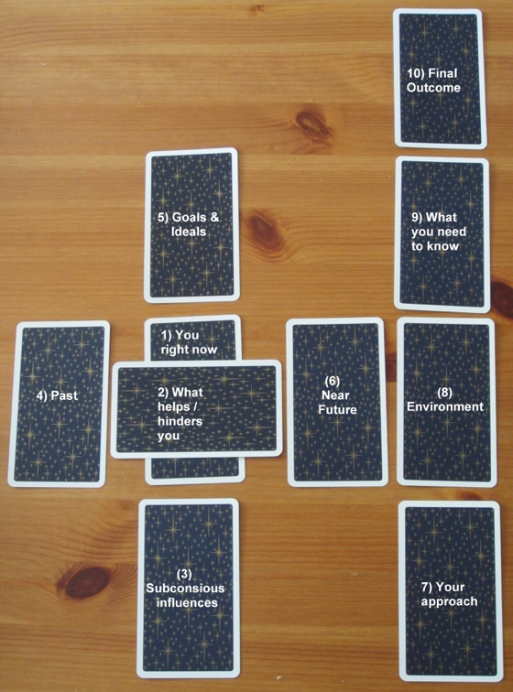the reader cuts the deck into three smaller decks, places them face down, and flips over the top card on each. The leftmost card represents past events that are still affecting the reader, the middle card is the present situation or challenges, and the last card is the future or what direction things are moving in. Again, the cards are not supposed to “tell the future” but give guidance to oneself. The Celtic Cross spread is a ten-card pull as shown in the photo. After the deck is shuffled, the reader pulls cards out, one-by-one, and places them down in order from one to ten. The first card is what the reader is thinking, feeling or doing in the present; the second is what is blocking the reader or helping the reader, based on the card pulled; third is subconscious wants, beliefs and feelings that the reader may not be aware of, but are affecting the situation; fourth is events, people or issues that have led to the current situation, which are either things the reader needs to let go, or draw from for support; fifth are conscious desires and what is important in the moment; sixth is the direction things are moving, which is still malleable; seventh is how the reader is currently approaching the situation; eighth is what energies are surrounding the reader, can be other people or influences in life; ninth is what the reader should be aware of, it is thought of as an advice card; and the tenth is the final outcome based on the current energy that is given off.

Each of the cards have a unique meaning. The cards each have a number, masculine or feminine energy, positive or negative energy, colors, symbols, elements, planets, chakras, and the zodiac. These factors can all affect what the cards are trying to convey to the reader, and what the reader may or may not pick up on. When the drawn cards are reversed or upside down, their meaning changes, and usually becomes the opposite of what the card originally meant. Some say that each card has its own voice and personality to tell its story.

The tarot deck traditionally has 78 cards, 22 in the major arcana and 56 in the minor arcana. The cards in the minor arcana, also called pips, are similar to playing cards. It has four suits with ace-10, page, knight, queen, and king in each. Each of the suits corresponds with one of the elements. Swords correspond to air, cups to water, wands to fire and pentacles to Earth. The minor arcana usually deal with more day-to-day insights, and the major arcana deal with larger or spiritual events. The court cards represent people in the reader’s life or the reader themself.

The major arcana is comprised of 22 cards, numbered from 0-21. According to Liz Roberta, The Fool’s Journey is told throughout the major arcana. Card 0 is the Fool. He represents new beginnings and good intentions. In the Rider Waite Smith deck, he is depicted almost falling off a cliff because he doesn’t have any experience in his journey. Then he steps into being the Magician (card 1). He then uses cups, pentacles, swords, and wands to make his dream a reality. Through his explorations, he meets the High Priestess (card 2) who shows up when he starts to discover the physical and the spiritual world. She holds divine wisdom and intuition. Then his mother appears as the Empress (card 3) who represents Mother Earth. His father appears as the Emperor (card 4) who is more authoritarian. He reminds the fool of tradition and rules. The fool looks for more information on the spiritual world, where he meets the Hierophant (card 5, also known as the pope). The Fool starts looking for companionship found in the Lovers (card 6), where he learns cooperation and balance. He now understands willpower and discipline, he rides the Chariot (card 7) toward his goals. He now possesses inner Strength (card 8). The fool isolates himself to look inward and becomes the Hermit (card 9). He realizes everything is divinely connected. The Wheel of Fortune (card 10) shows him that all things will happen when they are meant to. He also knows that the universe brings balance through Justice (card 11). With people around him, he surrenders himself and becomes the Hanged Man (card 12), where he can see from different points of view, where he has an ego Death (card 13). Temperance (card 14) shows him patience and contentment without action. As he tries to move forward, he realizes he is still tied to his past, which is limiting his expansion. The Devil (card 15) makes him look at himself and let go of things that no longer serve him. The Tower (card 16) cut these ties, out of the Fool’s control. The Star (card 17) lights his way which provides him hope, opposite of the Moon (card 18) represents fears and subconscious programming preventing his happiness. Once the fool has worked through his fears, his light expands and he becomes the Sun (card 19). He feels renewed and in touch with his soul’s purpose. His ego is completely shed. Like a final Judgement (card 20) there’s no room for illusions or false identities. He is answering his soul’s calling. He has mastered the World (card 21). It is the end of the road for the Fool (Roberta). This story can be a model for everyday life and how to achieve enlightenment, or it could just be the way people remember the meaning of the 22 cards.

Stuart R. Kaplan, businessman who imported and sold tarot cards, says, I think tarot is popular because each deck in an unpaged book. Shuffle them and you’ll get a new story every time” (Topolsky).

Works Cited

“A Brief History of Tarot Cards.” *Bicycle Playing Cards*, Bicycle Playing Cards, bicyclecards.com/article/a-brief-history-of-tarot-cards/.

Roberta, Liz. *How Tarot Cards Work: The Fool's Journey & Story of the Major Arcana*. 3 Feb. 2021, lizroberta.com/2020/10/28/how-tarot-cards-work-the-fools-journey-story-of-the-major-arcana/.

Stenudd, Stefan. “Tarot Celtic Cross.” *The Celtic Cross Tarot Card Spread*, www.tarotcardmeanings.net/tarot-celtic-cross.htm.

Topolsky, Laura June. “If You Can Picture A Tarot Card, It's Because of These 3 People.” *Atlas Obscura*, Atlas Obscura, 10 July 2015, www.atlasobscura.com/articles/the-deck-of-cards-that-made-tarot-a-global-phenomenon.